[2016 하반기 사이버한국유학박람회 개최 안내]

교육부 국립국제교육원에서는 외국인 유학생을 대상으로 한 『2016 하반기 사이버 한국유학박람회』를 다음과 같이 개최합니다.

가. 행사명: 2016 하반기 사이버 한국유학박람회
나. 일자: 2016.11.14.(월) ~ 11.25.(금), 2주
다. 주요 메뉴소개
- 한국유학 홍보 부스: 한국유학안내, 정부초청장학금 제도, 온라인 상담게시판 운영
- 대학 홍보 부스: 실시간 입학상담, 외국인 유학생 모집요강, 온라인 상담게시판 운영
라. 참가대학: 고려대 등 44개교
마. 접속 및 참가방법(세부사항 첨부파일 참고)
- 스터디인코리아 웹사이트(www.studyinkorea.go.kr) 접속하여 박람회 링크 선택
- 등록(online.studyinkorea.go.kr) 후 박람회 기간 중 사이트 방문

[Online Education Fair Korea 2016]
It is our pleasure to announce that NIIED will hold the [Online Education Fair - Korea 2016] for international students. This is the last chance to participate the fair in 2016!
- Name of the event: The Second Biannual Online Education Fair – Korea 2016
- Date: Nov. 14 (Mon) ~ Nov. 25 (Fri), 2 weeks
- Introduction of main contents
- Promotional booth for Studying in Korea: information of studying in Korea and government scholarship programs, online consultation
- Promotional booth for Korean universities: real-time consultation, admission guideline for international students, online consultation
- Participating universities: 44 universities including Korea university
- How to access and participate the online education fair (Please see the attachment)
- Visit the Study in Korea website (www.studyinkorea.go.kr) to select the online education fair link
- Complete the registration and visit the website during the online education fair

<Attachment>
How to register “Online Education Fair Korea 2016”
- Visit “www.studyinkorea.go.kr”
- Click “Online Education Fair Korea 2016”
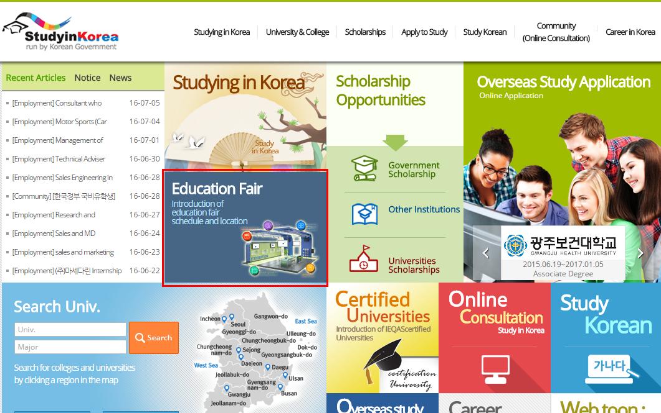
- Click “Registration” to join the Fair. For those who completed the registration, we will send detailed information about online education fair by email. 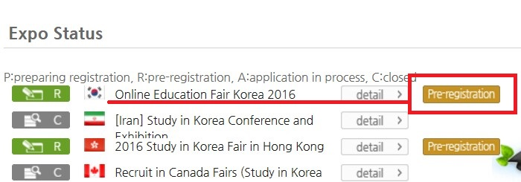

- During the education fair period (Nov. 14th - 25th), click “details” to join the Fair.
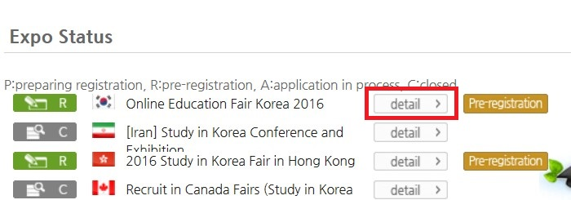
- Click icons to see the details.
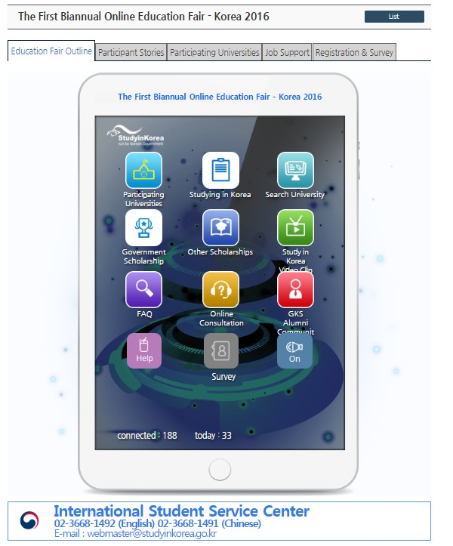
- Click the icon ‘Participating universities’ to check Korean universities.
- Click the ‘Introduction’ button to check details about the university you are interested in.
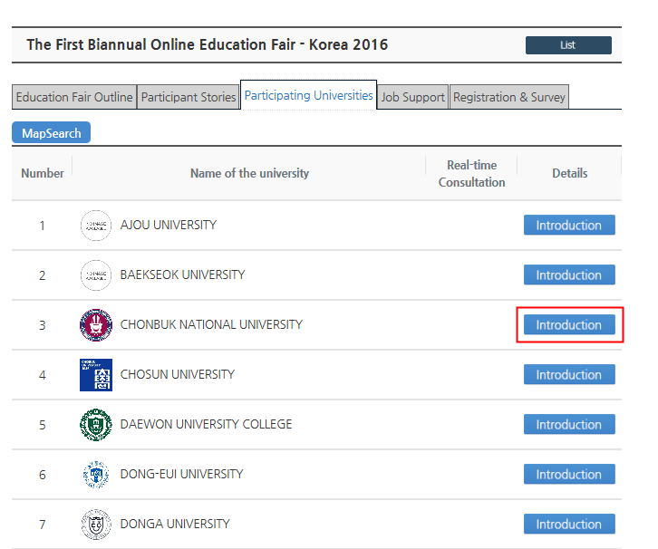
- Click icons to check the details.
